EVENTS ORGANISED BY OMR DEPARTMENT

WORLD NO TOBACCO DAY 2026
World No Tobacco Day 2026 Campaign from May 20th to June 1st, themed "Unmasking the Appeal: Countering Nicotine and Tobacco Addiction" organized by the Departments of Oral Medicine & Radiology and Public Health Dentistry, the initiative focused on awareness, tobacco cessation, and early oral cancer detection.
Key activities included free oral screening camps, personalized tobacco cessation counseling, and basic dental treatments. To actively engage the community, students performed a Nukkad Natak (street play) and distributed educational materials. The campaign also featured health talks and a multidisciplinary panel discussion among experts addressing public health strategies.
A major milestone of the event was the inauguration of the Centre of Excellence on Tobacco Cessation and Education, establishing a dedicated platform for future research, patient support, and continuous awareness.
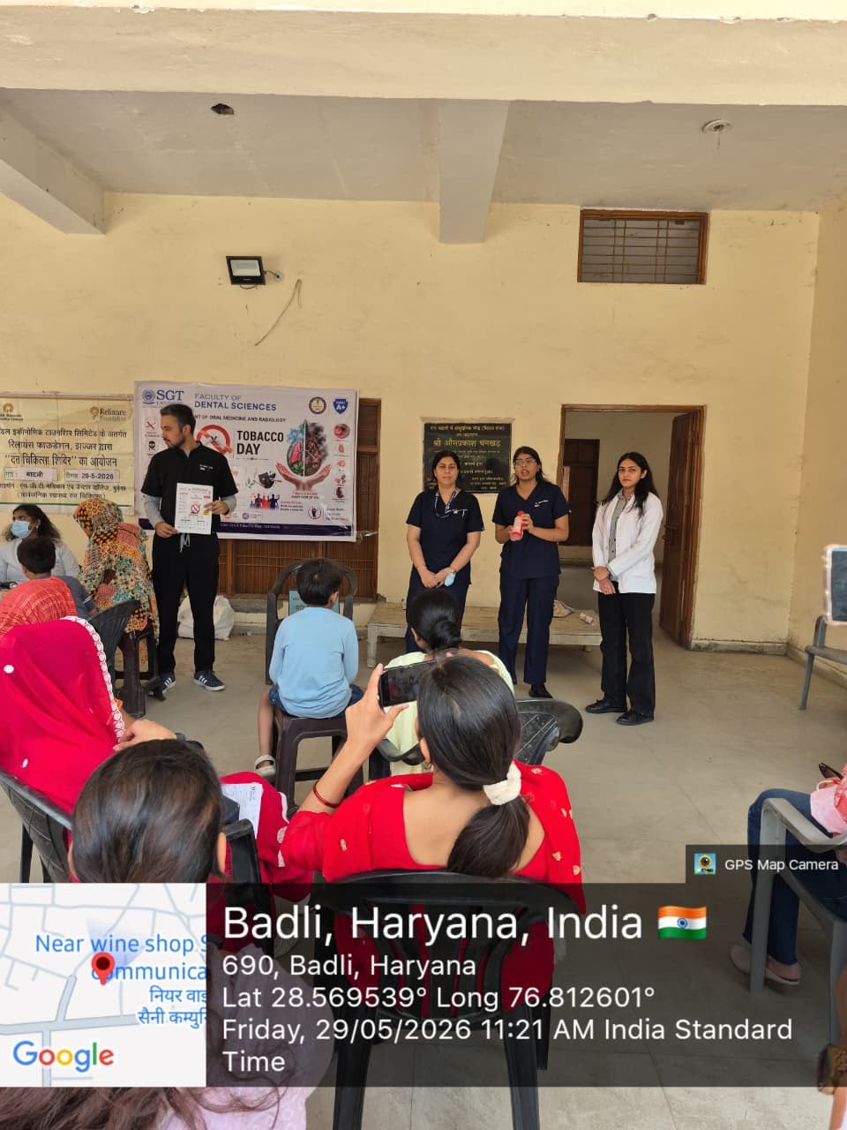
The initiative successfully motivated behavioral changes among tobacco users and facilitated the early diagnosis of potentially malignant oral disorders. Ultimately, this campaign reinforced strong commitment to preventive community healthcare and the promotion of a tobacco-free society.
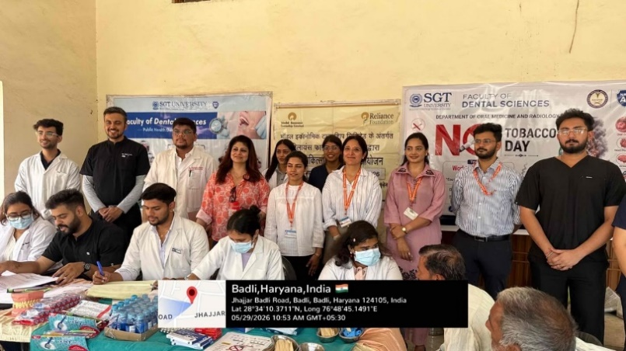

“DECODING PSYCHOSOMATIC DISORDERS IN DENTISTRY – ROLE OF MENTAL HEALTH.” CONDUCTED ON 1ST MAY 2026

Bridging Dentistry & Mental Health- The Advanced Stomato Diagnostician Club, under the aegis of the Department of Oral Medicine and Radiology, successfully organized an insightful interdepartmental session on “Decoding Psychosomatic Disorders in Dentistry – Role of Mental Health.” Conducted on 1st May 2026, the event saw enthusiastic participation from both UG and PG students, who actively engaged in thought-provoking discussions with our esteemed speakers: Dr. Prerak Kumar – Assistant Professor, Department of Psychiatry, Dr. Vikas Sharma – Associate Professor & Head, Department of Clinical Psychology. The session explored the intricate connection between mental and oral health, focusing on conditions such as: TMJ disorders, Oral psychosomatic lesions, Cancerophobia. Students gained a deeper understanding of diagnosing and managing such conditions while emphasizing the importance of holistic, patient-centered care in dentistry. The program was conceptualised by Dr. Puneeta Vohra (Professor & Head) and seamlessly coordinated by Dr. Priyanka and Dr. Bhawna, whose efforts made the session highly interactive, impactful and interdepartmental education health awareness.
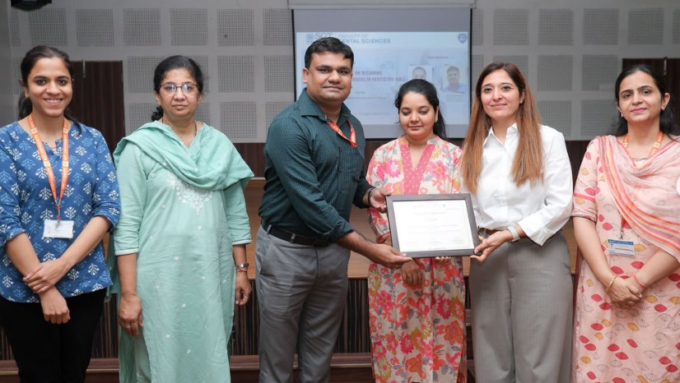

ORAL MEDICINE AND RADIOLOGY CELEBRATION
The Department of Oral Medicine and Radiology celebrated Oral Medicine and Radiology Day on 24 April 2026. The event began with an outreach program highlighting the role of Oral Medicine and Radiology in early diagnosis and the oral–systemic health link, followed by a pledge oath ceremony. Undergraduate students participated in gamified quiz, poster, reels, and video competitions, encouraging academic and creative engagement. Overall, the program successfully promoted awareness, student participation, and the importance of Oral Medicine and Radiology in comprehensive healthcare.
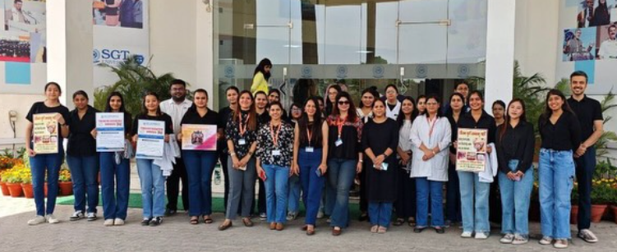
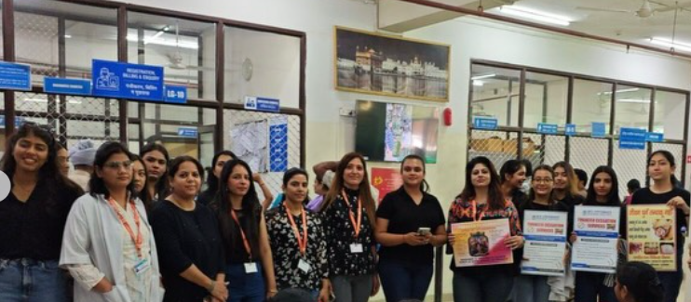

WEBINAR ON - CBCT: BASICS AND APPLIED ASPECTS

The webinar on “CBCT: Basics and Applied Aspects” was successfully conducted by the Office of International Relations – Health Sciences in association with Thai Moogambigai Dental College and Hospital, Organized as a part of the National MOU collaboration with SGT University, Gurugram, the session featured an expert lecture by Dr. Puneeta Vohra on the fundamentals and clinical applications of CBCT, promoting knowledge sharing and academic excellence in dental practice.
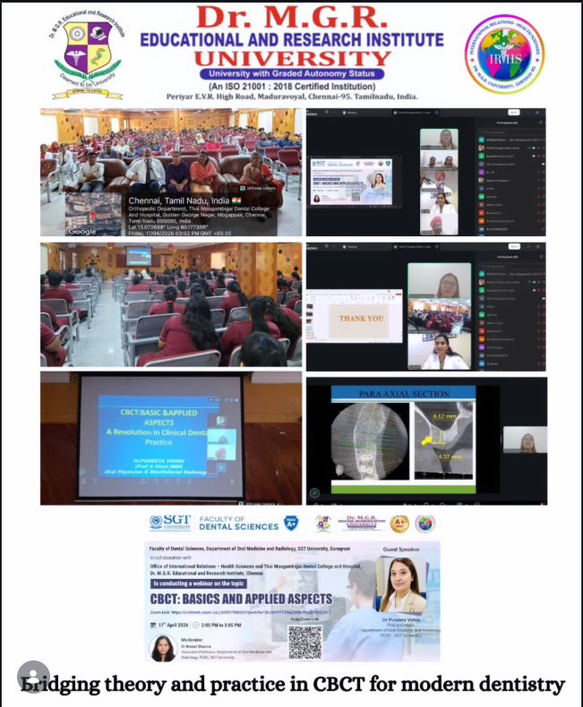

TRIPLE OOO SYMPOSIUM 2026

The Faculty and Postgraduate students of the Department of Oral Medicine and Radiology proudly participated in the prestigious Triple OOO Symposium 2026, held on 27th, 28th, and 29th March 2026.
We are honored to share that Dr Puneeta Vohra (Prof and Head) served as the esteemed Pre-Conference Chairman, adding immense value to the scientific deliberations. Our faculty members actively contributed as Chairpersons in the postgraduate paper and poster competitions. The postgraduate students represented the department in both paper and poster presentations. We are especially proud of: Dr Pinki, Dr Sneha Singh, Dr Reecha Sharma for winning awards at their respective presentations and bringing laurels to the institution. This achievement reflects the department’s commitment to academic excellence, research, and continuous professional growth.
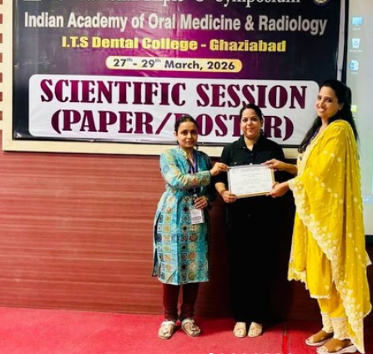
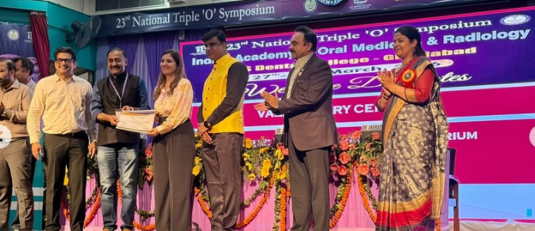

INTERACTIVE SESSION ON TREATMENT AND DENTAL CONSIDERATION FOR ORAL CANCER MANAGEMENT

Bridging Classrooms to Clinics | Experiential Learning in Action. In a step towards redefining academic engagement and clinical exposure, Oral medicine and radiology department recently curated an educational visit to the “American Oncology Institute, Gurgaon,” bringing together BDS undergraduate students, postgraduate scholars, and interns for a truly transformative experience. Guided by esteemed senior oncologists and domain experts, the participants had the rare opportunity to witness a live patient treatment session led by Dr. Babita Singh. The interactive setting enabled students to observe real-time clinical decision-making, patient management protocols, and interdisciplinary coordination—offering insights far beyond conventional classroom learning. Such experiences are instrumental in shaping future-ready healthcare professionals equipped with both competence and confidence. This impactful visit was conceptualised under the guidance of Prof and Head Dr. Puneeta Vohra and seamlessly coordinated by Dr. Sukriti (Reader) and Dr. Srividya (Reader), whose commitment to academic excellence continues to inspire meaningful learning pathways.
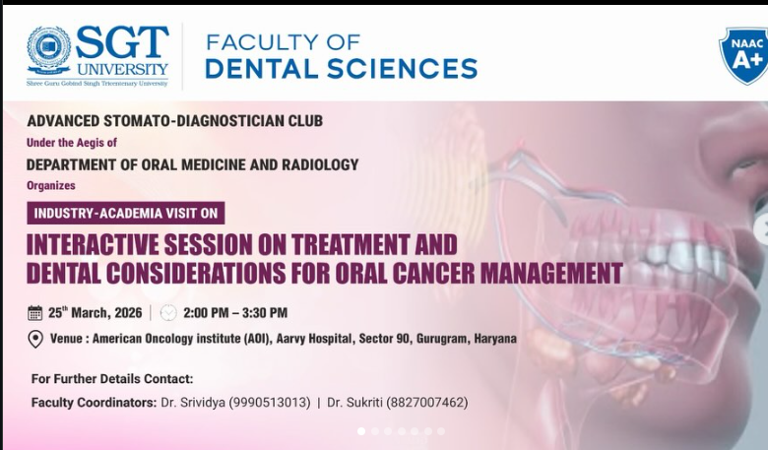
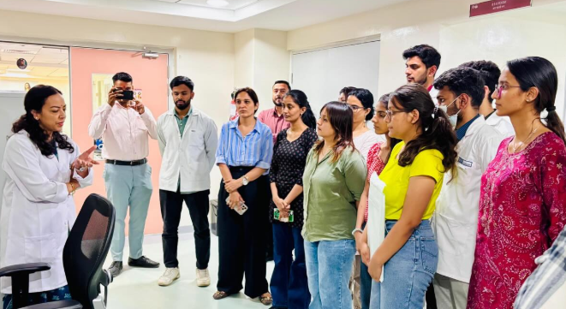
EXTERNSHIP PROGRAM WITH MUCM

13 students from Batch 13, Faculty of Dentistry, MUCM visited SGT University, Gurugram, India, for an enriching clinical exchange. They observed real cases and live surgeries, explored radiology and TrueBeam radiotherapy, and learned from advanced facilities like CAD/CAM crowns and dental microscopes.
The visit also sparked the birth of the MUCM Girls’ Cricket Team and ended with a heartfelt valedictory ceremony, marking an unforgettable journey of learning and friendship.
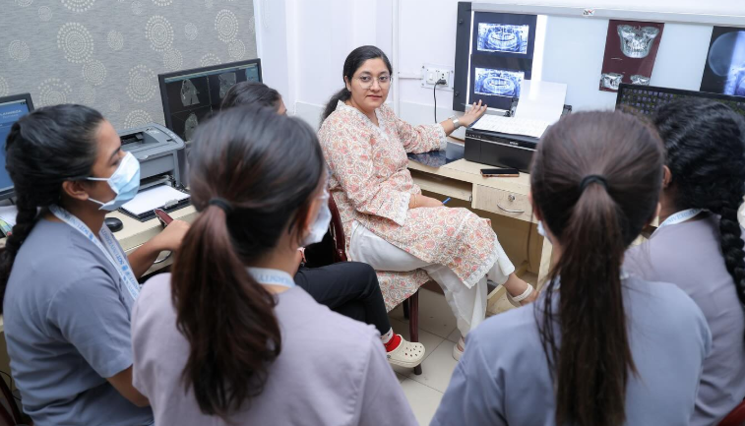
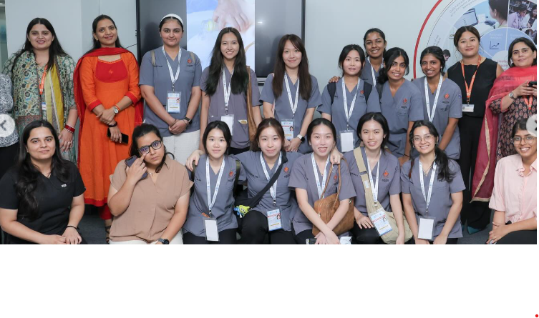
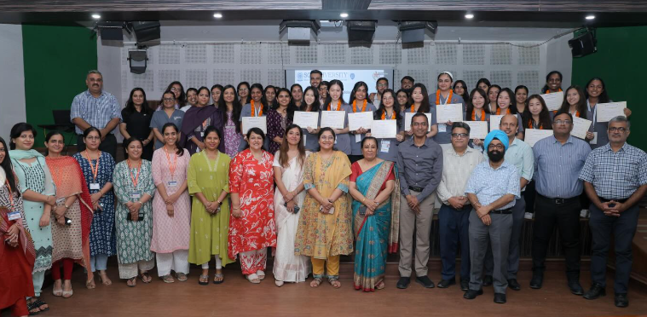

IAOMR UG CONVENTION 2025

The much-anticipated IAOMR National UG Convention 2025 was a grand success, bringing together brilliant minds from across India to explore the future of Oral Medicine and Radiology. The event was inaugurated by the esteemed Prof. Dr. Hemant Verma, Vice Chancellor of SGT University, who graced the inaugural ceremony as the Chief Guest. We were honored to have Prof. Dr. Ranjit kumar Patil, Ex Dean, Prof. & Head, Faculty of Dental Sciences, King George’s Medical University, Lucknow, as the Guest of Honour. Distinguished speakers and Heads of Departments from 28 premier dental colleges spanning Punjab, Himachal Pradesh, Haryana, Madhya Pradesh, West Bengal, Uttar Pradesh, and more, gathered to make this an academic extravaganza. Over 350 enthusiastic participants undergraduates, postgraduates and faculty engaged in insightful sessions, paper and poster presentations, dental quiz, and vibrant cultural programs. The convention truly lived up to its theme, “Bridging the Gap Between Diagnosis and Treatment Using Innovation, Technology, and Knowledge.”
Highlights included: Dr. Harneet Singh enlightening talk on -The Role of AI in Oral Medicine and Radiology. Dr Hemant Mathur presenting cutting-edge insights on Innovations and the Role of CBCT. Dr Pradhuman Verma had lecture on Diagnosis and Treatment Planning of Oral Lesions with latest treatment protocols. Dr. Shalu Rai, Vice President of IAOMR, emphasizing the critical Importance of Research in undergraduate students
hosted by the Department of Oral Medicine and Radiology, the convention fostered collaboration, learning, and innovation among the next generation of dental professionals.
